AZURE TERRAFORM

**Aim**: - Create Windows Virtual machine on azure portal by using the terraform.

# **Create Windows Virtual machine on azure portal by using the terraform.**

**Create a Windows Virtual machine:**

Configure the Windows virtual machine file by using the HCL.

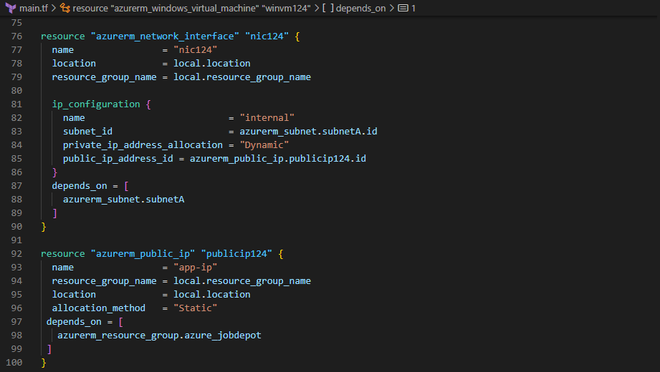

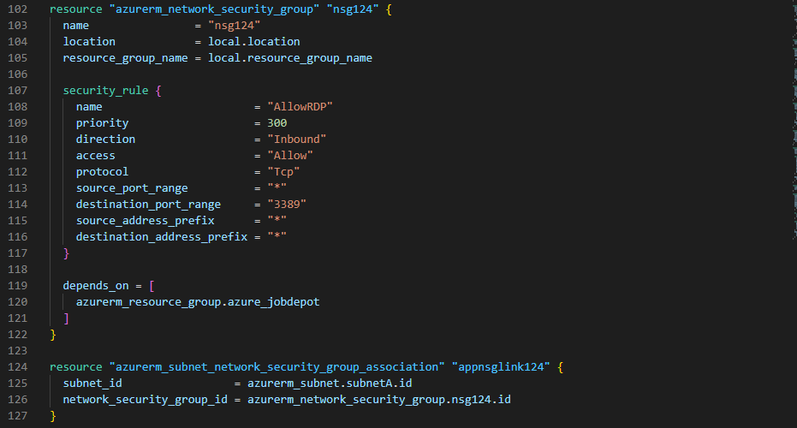

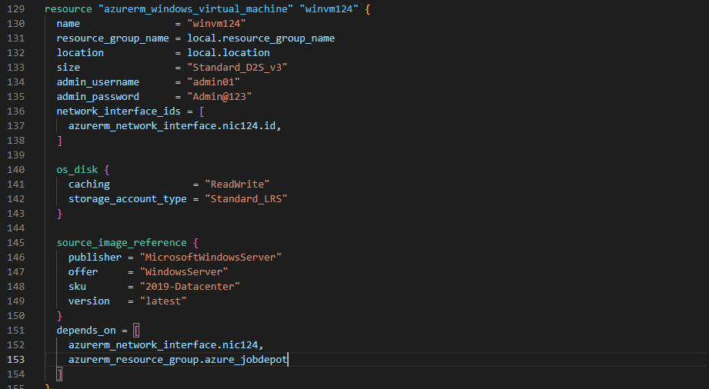

To validate the Windows virtual machine configuration file:

>terraform validate

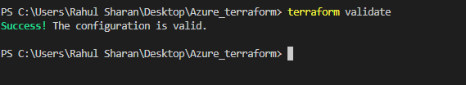

Initialize the terraform configuration file using the following command:

>terraform init

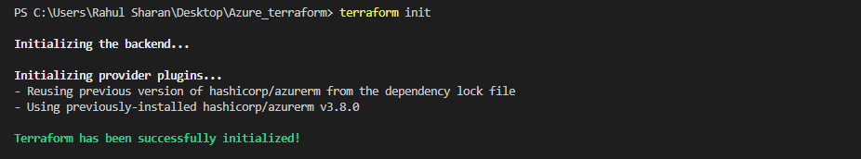

To create an execution plan for Windows virtual machine by using the following command:

>terraform plan –out main.tfplan

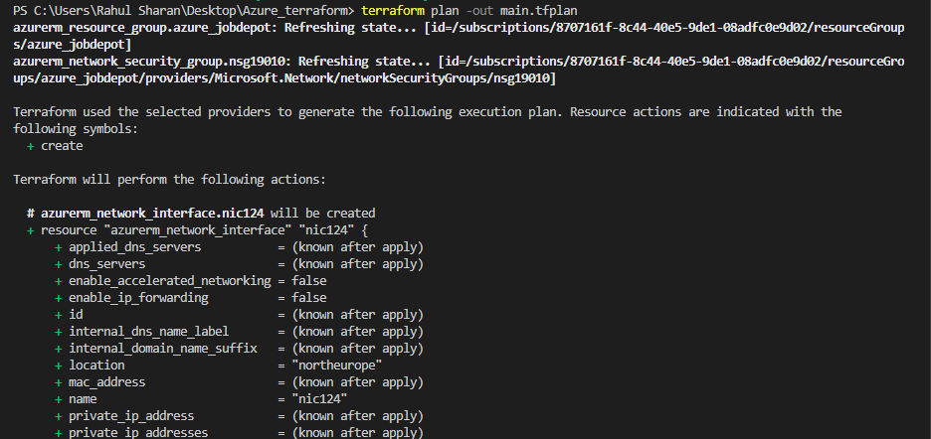

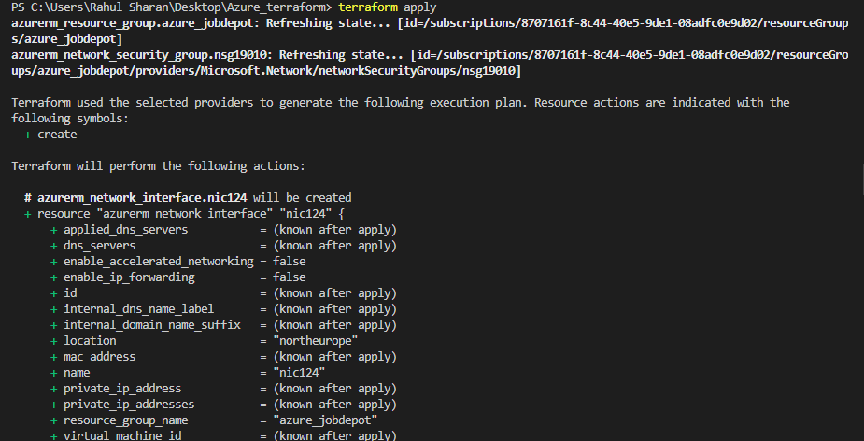

To verify the Windows virtual machine in azure portal:

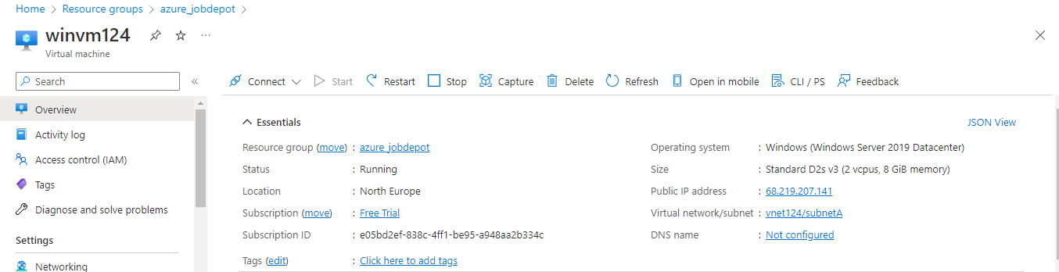

**Create a VM using the Splitting’s the files**

Splitting’s files into the two parts such as provider.tf and main.tf:

provider.tf

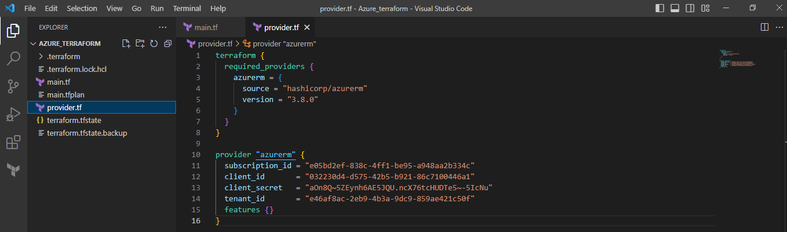

main.tf

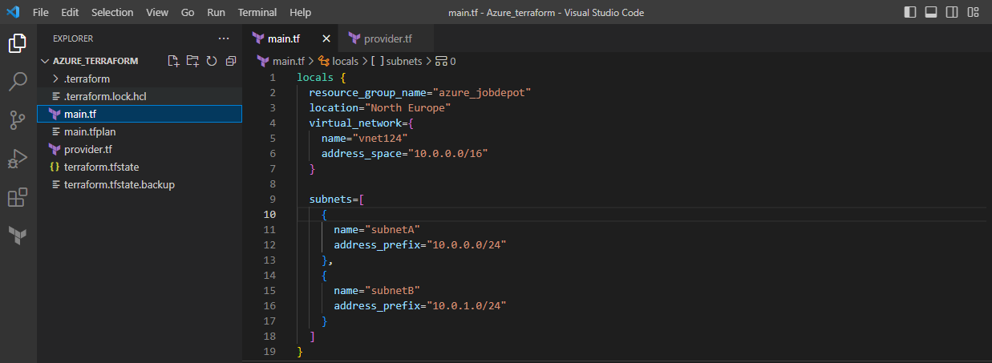

After the splitting’s files then the Initialize the terraform configuration file using the following command:

>terraform init

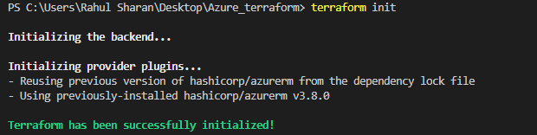

After the splitting’s files then execute the Windows virtual machine by using the following command:

>terraform apply

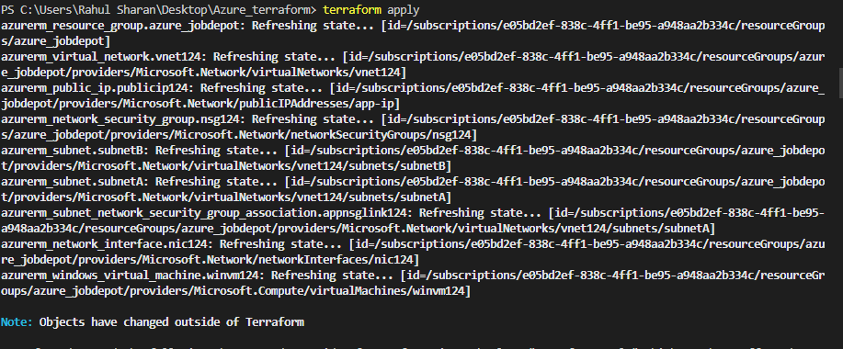

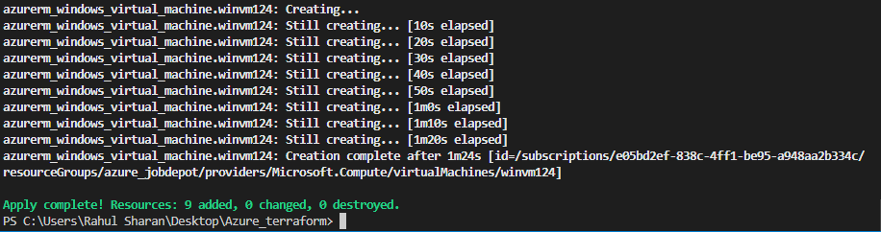

**Create VM Using Variable file:**

To create three files such as provider.tf and main.tf and variable.tf:

Variable.tf

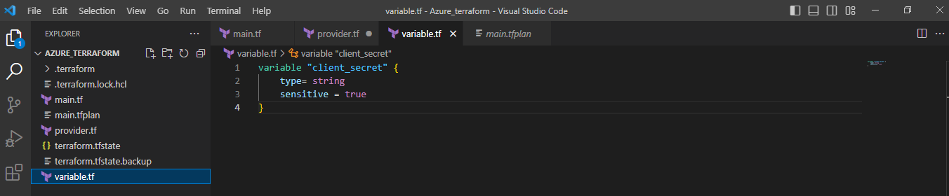

provider.tf

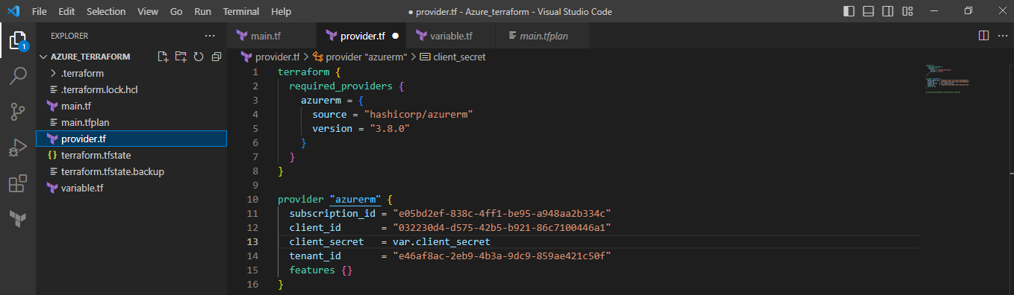

main.tf

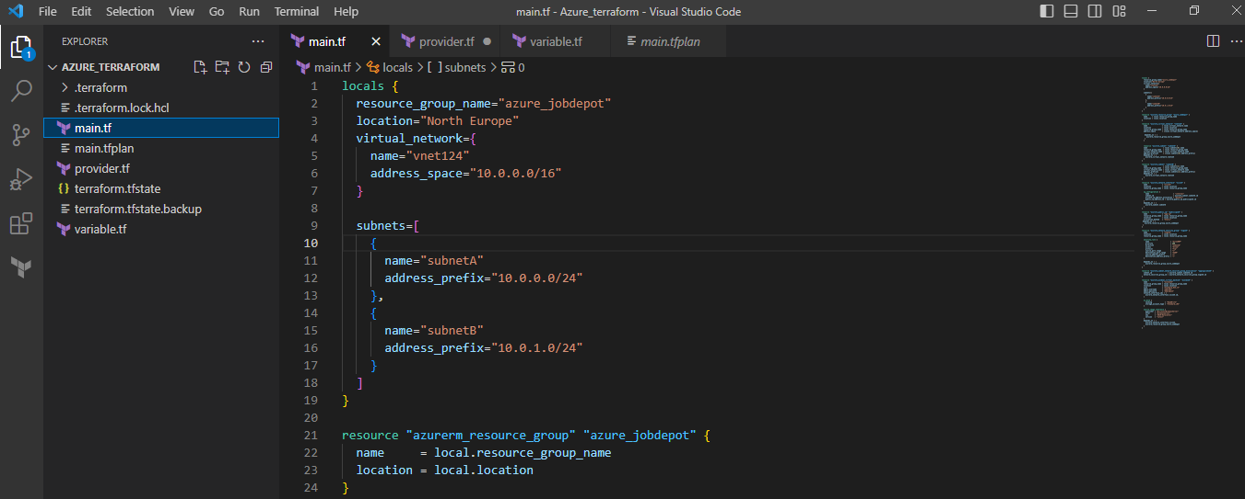

After the create files then Initialize the terraform configuration file using the following command:

>terraform init

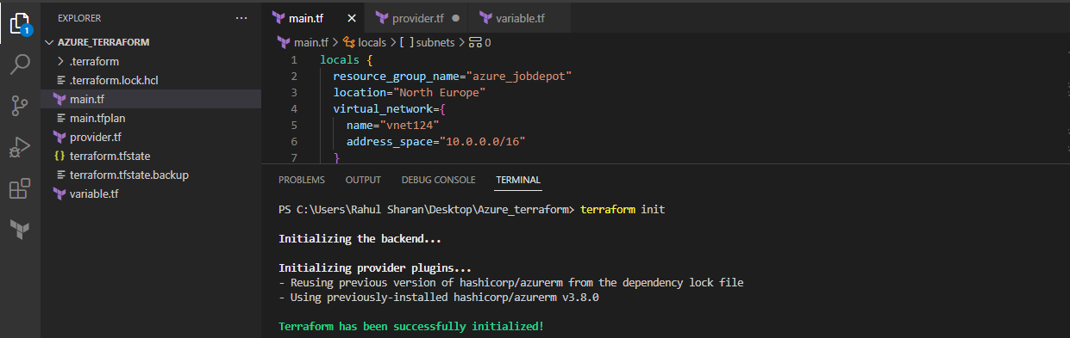

After create files then execute the Windows virtual machine by using the following command:

>terraform apply

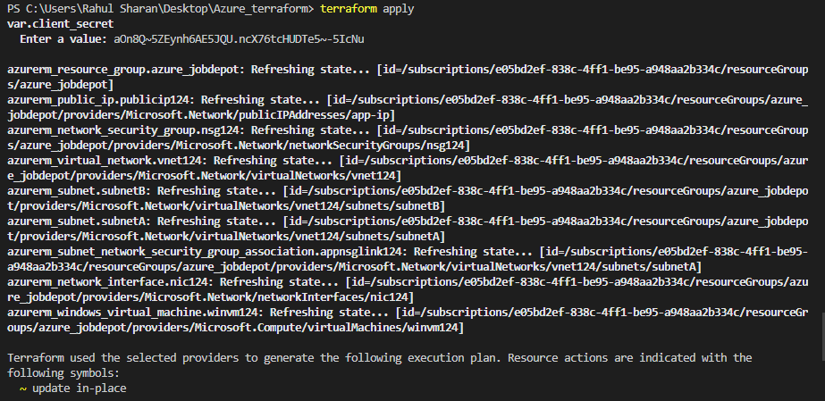

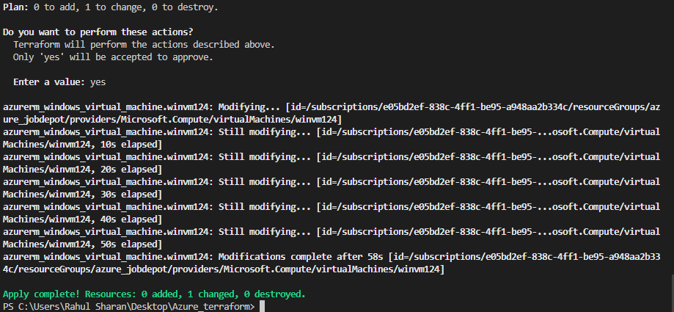

**Create Storage account Using Count meta-argument:**

To create three files such as provider.tf and main.tf and variable.tf:

Variable.tf

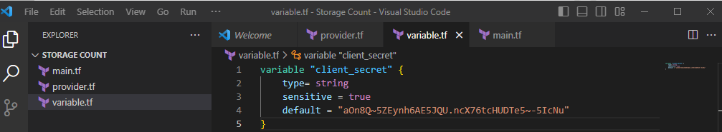

provider.tf

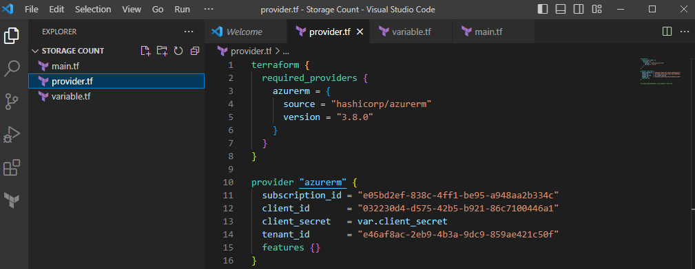

main.tf

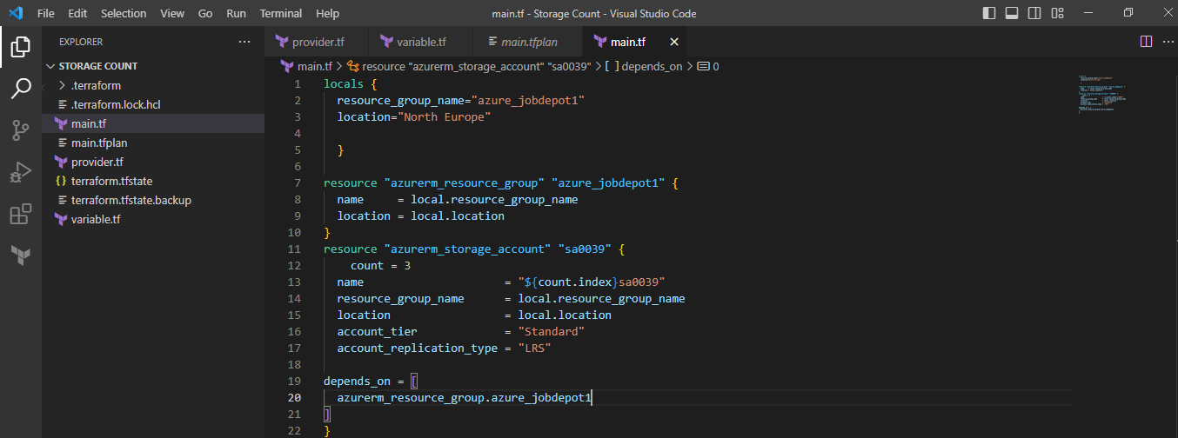

After the create files then Initialize the terraform configuration file using the following command:

>terraform init

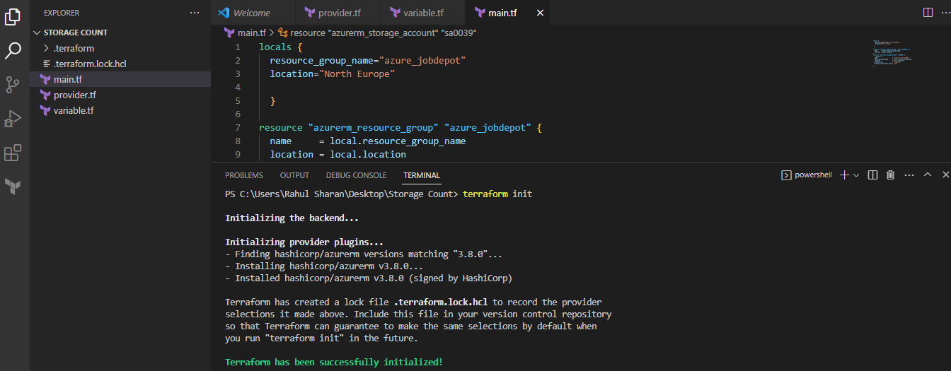

To create an execution plan for Storage account using count expression by using the following command:

>terraform plan –out main.tfplan

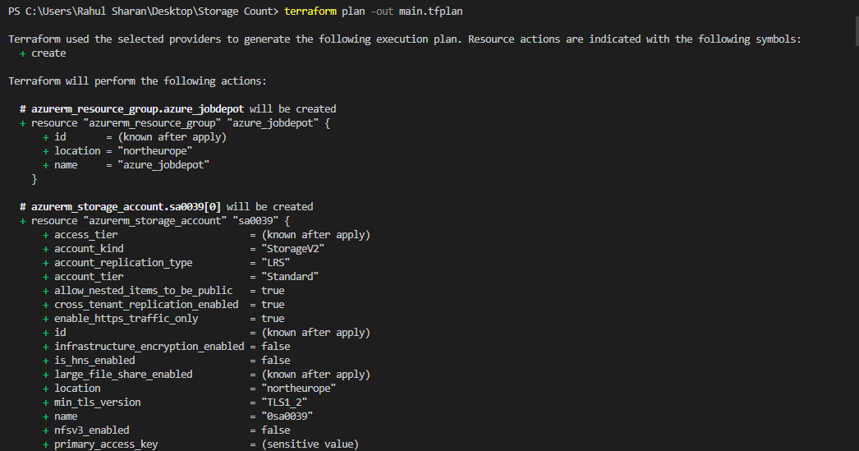

To execute the Storage account using count expression by using the following command:

>terraform apply

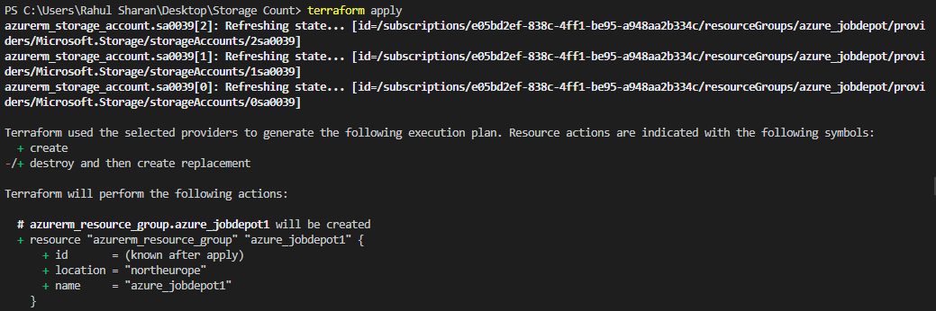

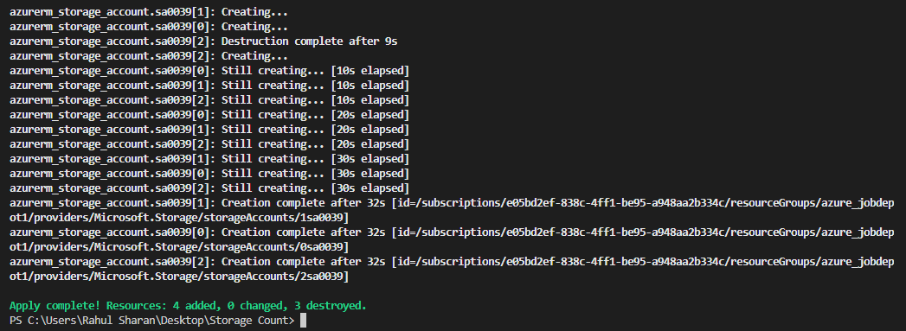

To verify the three storage account in azure portal:

